What is a Local List
A Local List is a list of heritage assets within the district considered by the public, and council, as having special local architectural, archaeological or historic interest, but that are not statutory listed. The heritage assets included in the Local List are considered to be of significance to the local community and to contribute to the environmental and cultural heritage of the district.
A local heritage asset is a building, structure or man-made landscape of local historic or architectural importance but not covered by statutory legislation.
The term 'Heritage Asset' is described in the National Planning Policy Framework (NPPF) as ' A building, monument, site, place, area or landscape identified as having a degree of significance meriting consideration in planning decision, because of its heritage interest'. Heritage assets include designated heritage assets and assets identified by the local planning authority (including Local Listing).
The Leyland Local List
South Ribble Borough Council is preparing Local Lists on an area basis for the Borough. A Local List for Penwortham was adopted as part of the Penwortham Neighbourhood Plan, which was adopted in 2016. The Leyland Local List will be based on the Leyland My Neighbourhood Area boundary.
A consultation was carried out via social media during the spring of 2017, to ask local residents to suggest buildings and structures for inclusion on the list. In addition, local historians and the Leyland Historical Society were consulted.
Once all suggestions were collated, anything that is protected by another designation, such as it already being a statutorily listed building or in a conservation area, was removed from the list.
How will Local Listing Affect my Property?

The Local List is advisory only, and does not provide the Council with additional powers. Existing powers are used as far as possible to preserve Locally Listed Buildings, especially when considering applications for planning permission. Developments to a Locally Listed Building – including external alterations, extensions and changes of use - should pay special regard to:
- preserving or restoring features which contribute to their character
- maintaining their scale and proportions
- preserving their setting
- using appropriate materials
This does not mean the building has to be preserved exactly as it is, but that any alterations should be carried out in a sympathetic manner.
Internal alterations and some minor types of external development, especially to houses, do not need planning permission from the Council. If this threatens the character of a Locally Listed Building, however, consideration will be given to making an Article 4 Direction. This removes the automatic right to carry out the development and will require planning permission to be obtained from the Council. Consideration will also be given to the possibility of adding the building to the statutory list and thereby making it subject to more stringent controls.

Guidance
The following principles should be followed when considering work to a Locally Listed Building:
- Regular maintenance is essential. It will safeguard historic fabric and avoid the need for more costly repairs later on.
- Proposals should preserve or restore the building's architectural or historic character. So the starting point should be to understand what features give the building its interest.
- It is important to retain and repair historic fabric as it gives authenticity to the building. This may include internal features like skirtings, doors, fireplaces ceiling cornices, historic plaster, and stair bannisters and handrails. Where the fabric has deteriorated, repair rather than replacement should always be the first option.
- Necessary alterations to historic fabric should be reversible, as far as practical. For example, if fire proofing is needed, original ceilings, walls and doors may be retained behind fire-resistant fittings.
- The historic plan form of the building (its internal layout) should normally be retained.
- Additions and external alterations should preserve the scale and character of the building and should normally use appropriate traditional materials and designs.
- The setting of the building should normally be preserved where this contributes its character.
- Employ only suitably skilled designers and craftsmen.
Buildings/Structures not Included in the List
Buildings already on a Statutory List of Historic Buildings would not be considered for inclusion on a local list as they already have a level of protection. Also, buildings within a Conservation Area have not been included as they are already afforded a level of protection which would not be increased by inclusion on a Local List.

Leyland Local List

Building Name | Number | Street
Leyland House  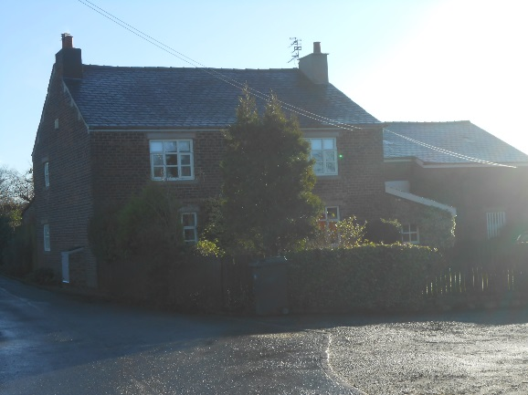 |  | Altcar Lane
Leyland Motors Day Continuation School  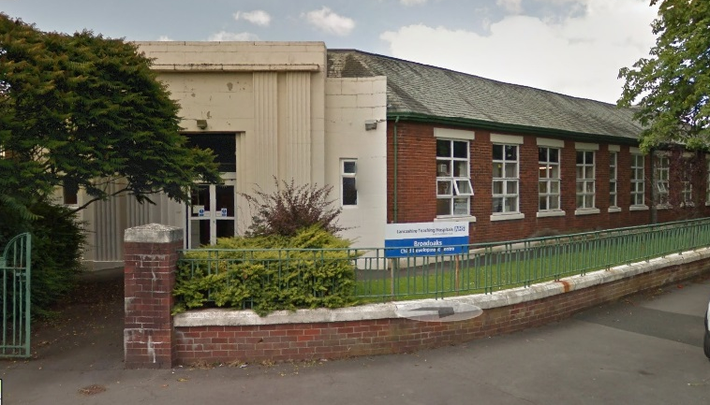 |  | Balcarres Road
Beechfield Gate House  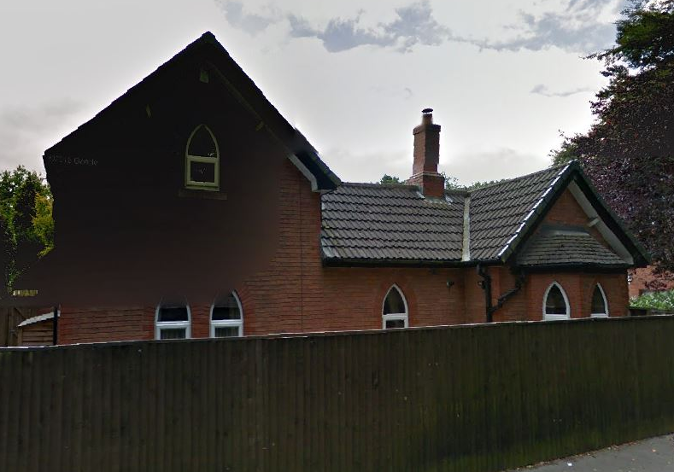 |  | Beechfield Court
Beechfield House  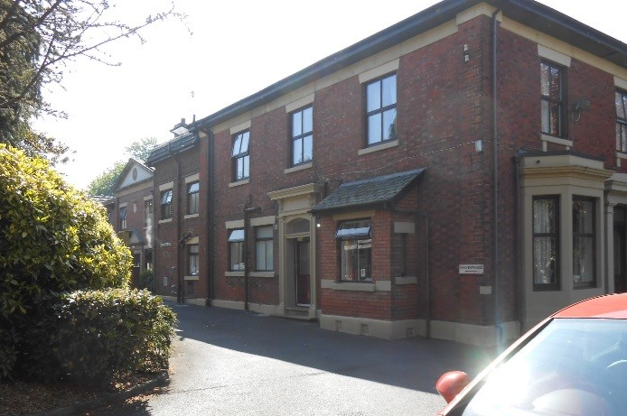 | 7 | Beechfield Court
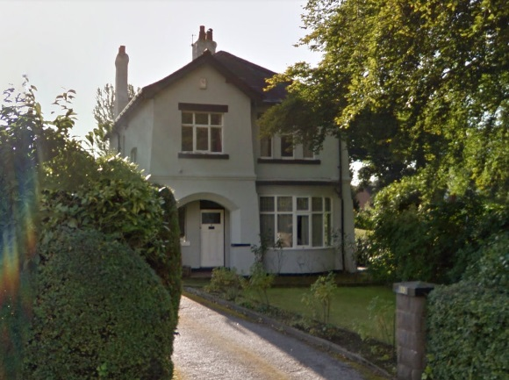 | 13 | Bow Lane
Leyland Motors Spurrier Works Office Buildings  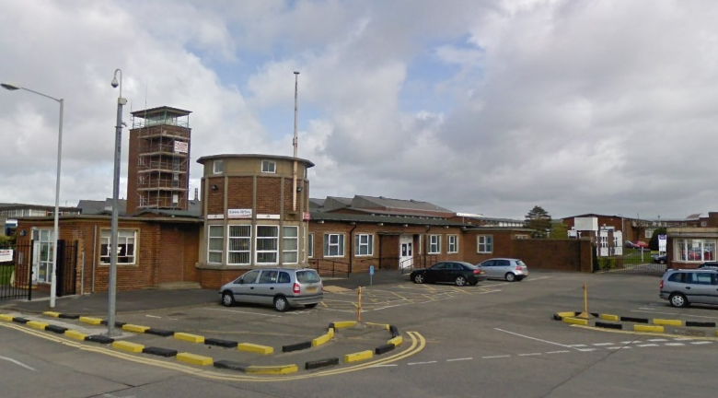 |  | Centurion Way
BTR Office Building  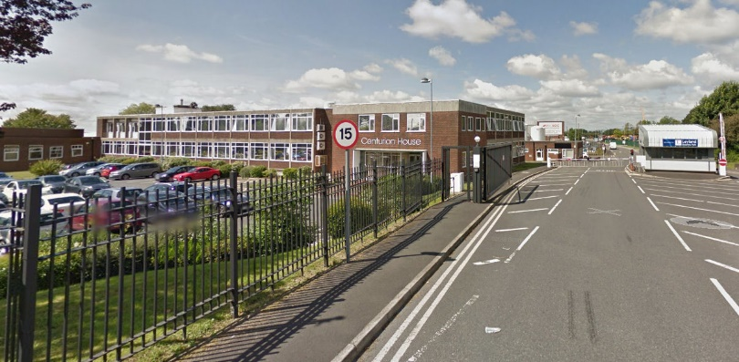 |  | Centurion Way
Co-Op Headquarters | 20-22 | Chapel Brow
Gold Thread Works  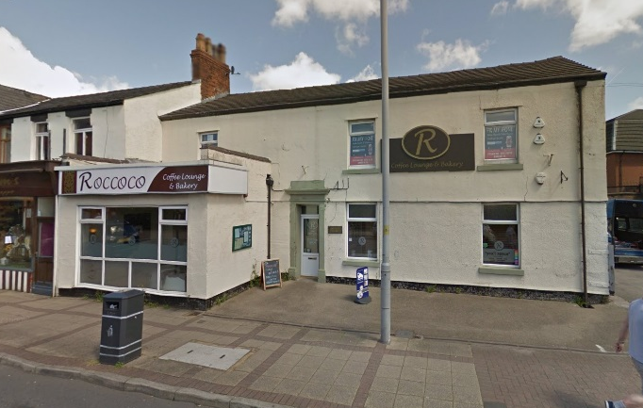 | 41-45 | Chapel Brow
Balshaws School  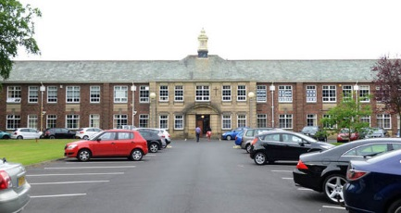 |  | Church Road
Wellington & Claremont Avenues  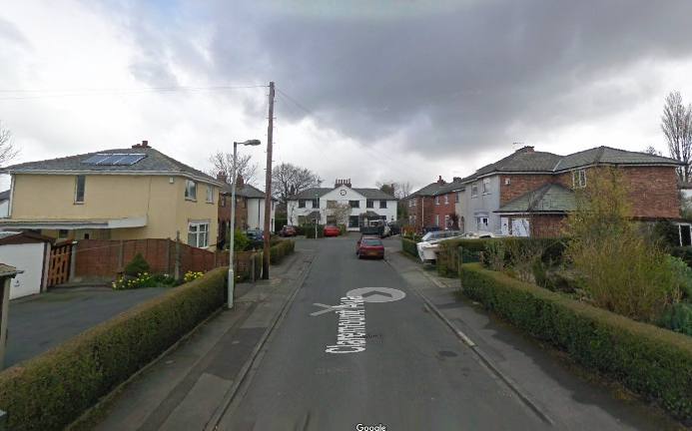  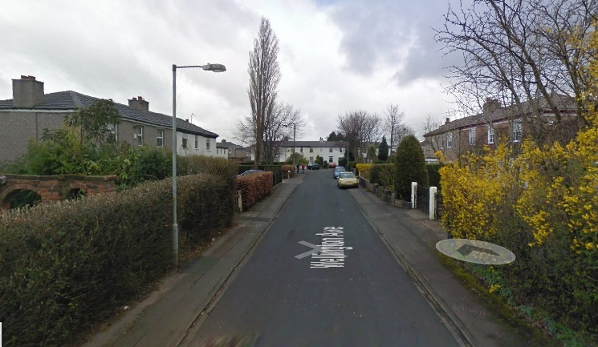 |  | Church Road
Wellington Lodge  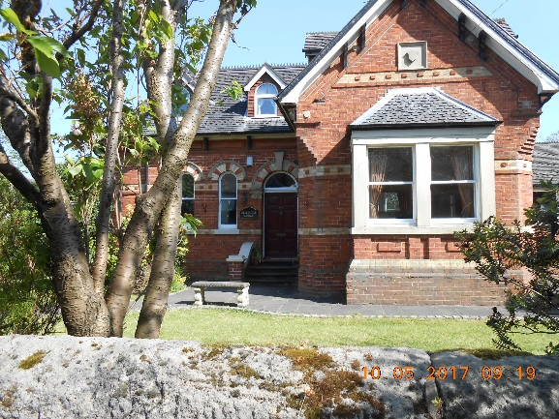 | 115 | Church Road
New House  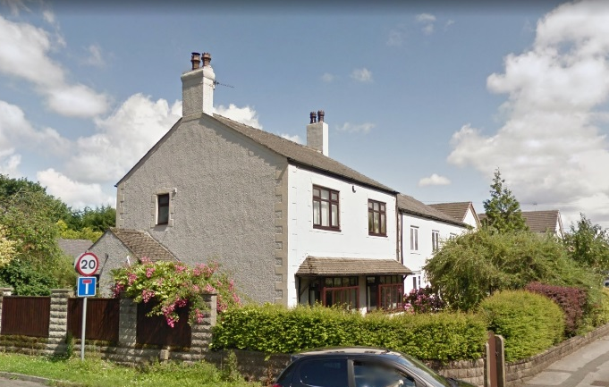 |  | Dunkirk Lane
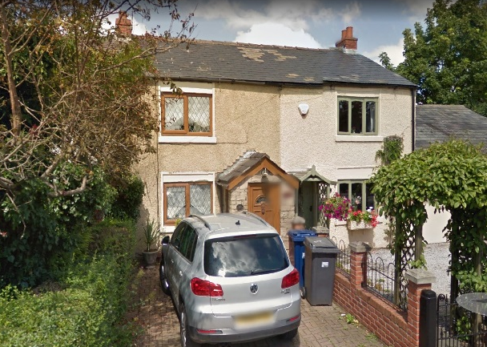  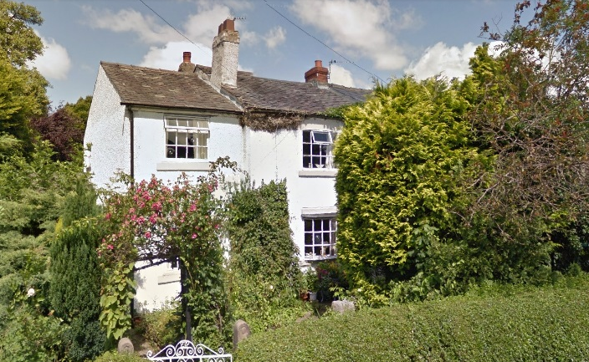 | 262-278 | Dunkirk Lane
Old Blacksmiths  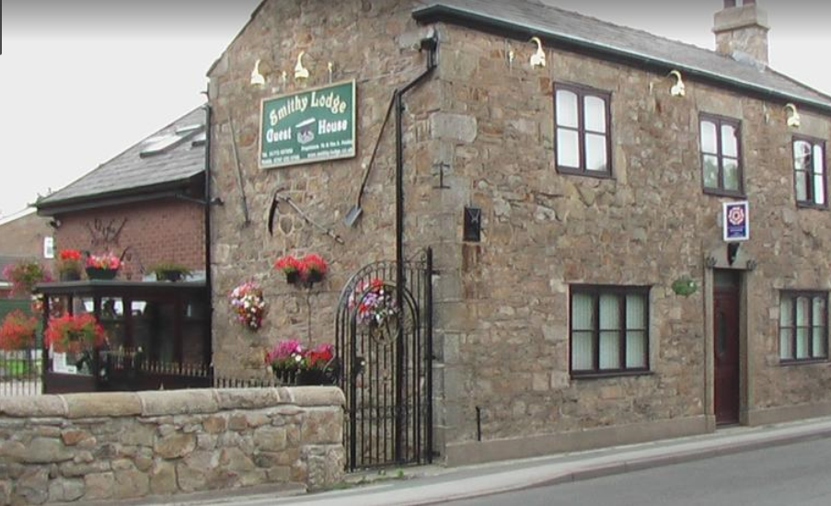 |  | Dunkirk Lane
Mill Buildings  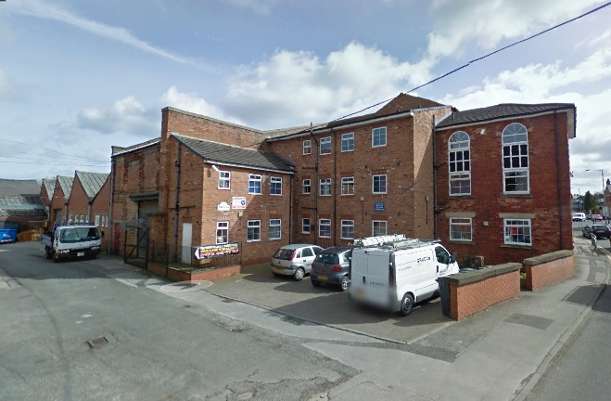 |  | Earnshaw Bridge
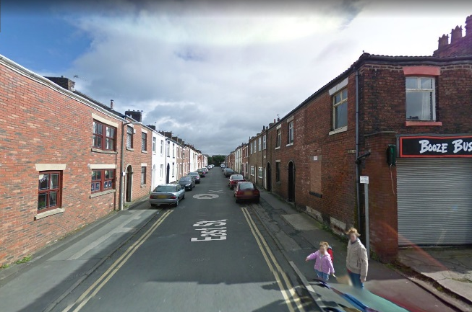 |  | East Street
White Houses | 1-3 (odds) | Fowler Lane
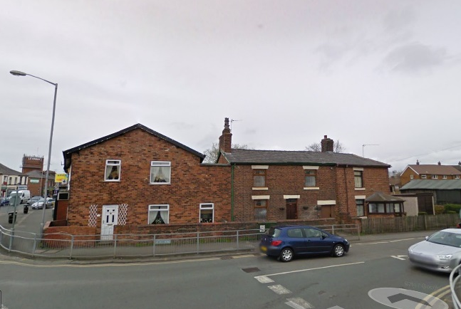 | 312 | Fox Lane
Coal Office  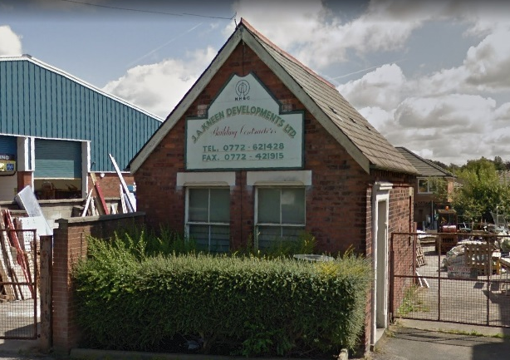 |  | Golden Hill
Old Police Station / Le Corte  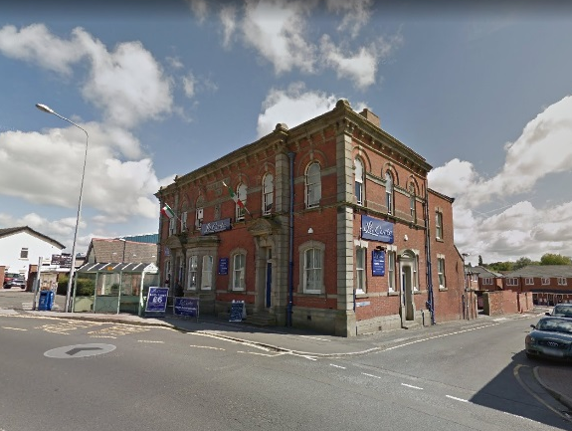 |  | Golden Hill
Golden Hill Cottages | 126-132 (evens) | Golden Hill Lane
Golden Hill Terrace  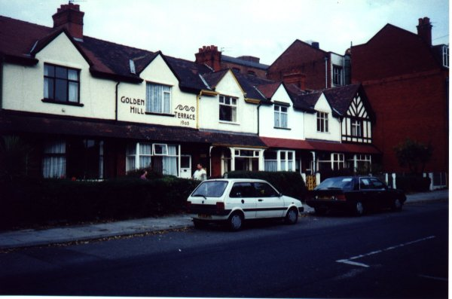 |  | Golden Hill Lane
Manchester & County Bank  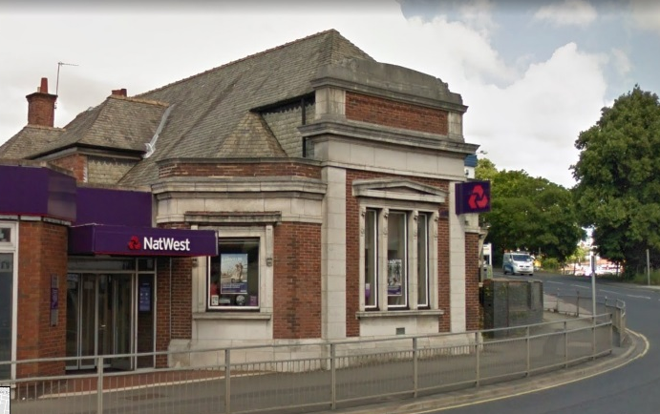 | 2 | Golden Hill Lane
Queens Hotel  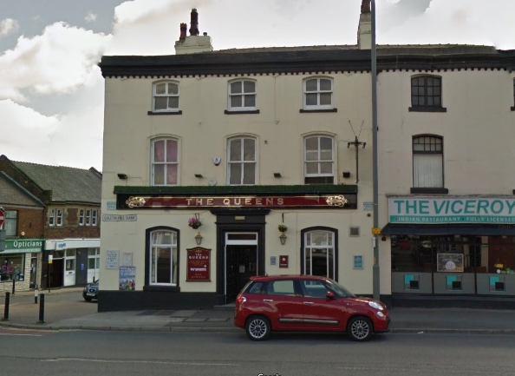 |  | Golden Hill Lane/Chapel Brow
Cranky' (green clock)  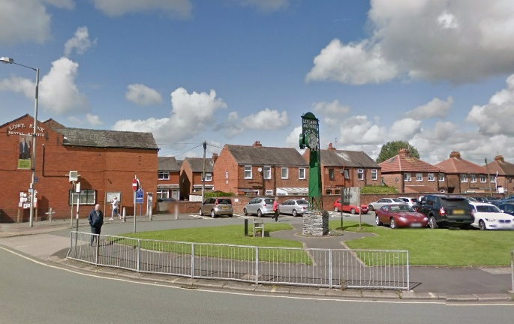 |  | Hough Lane
Gables  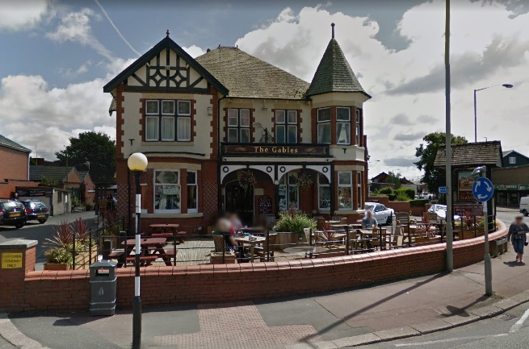 |  | Hough Lane
Grundy Terrace  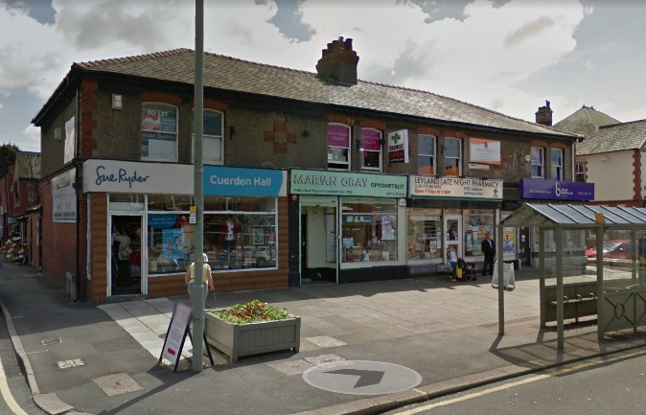 |  | Hough Lane
Leyland Lion Pub  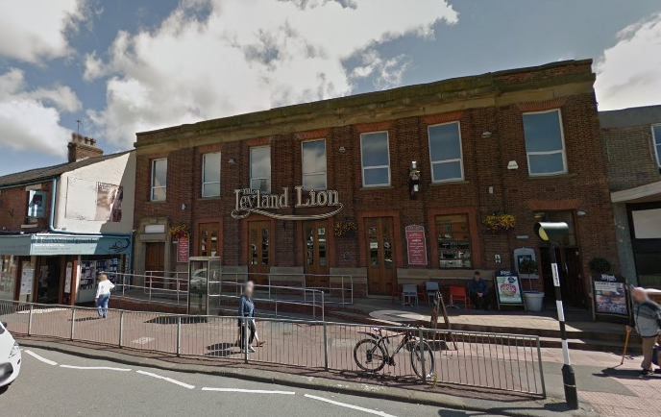 |  | Hough Lane
Victoria Terrace  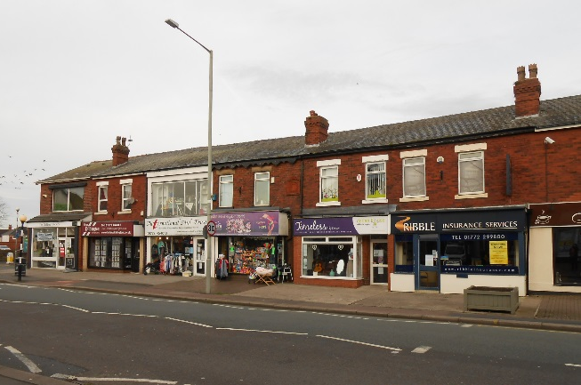  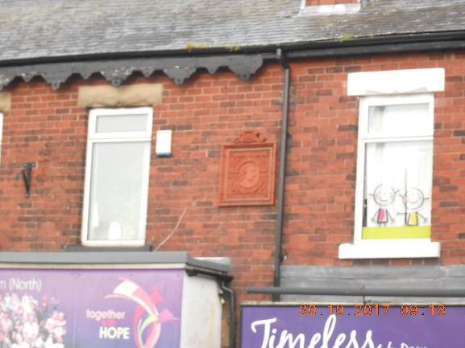 | 1-15 (odds) | Hough Lane
Blacksmiths  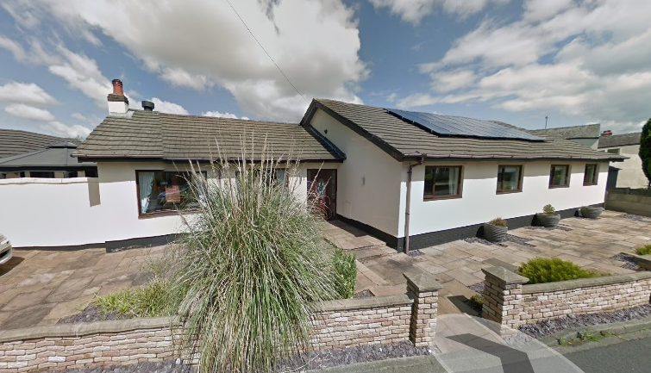 | 2 | Hugh Lane
Hugh House (Formerly H H Farm) |  | Hugh Lane
Leyland Magistrates Court |  | Lancastergate
Duttonfield Chapel & Wheatsheaf  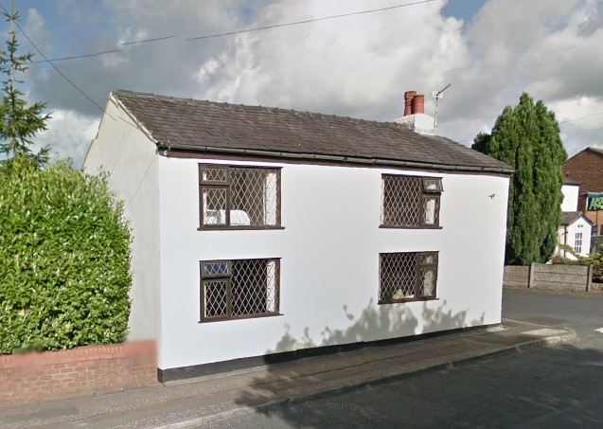  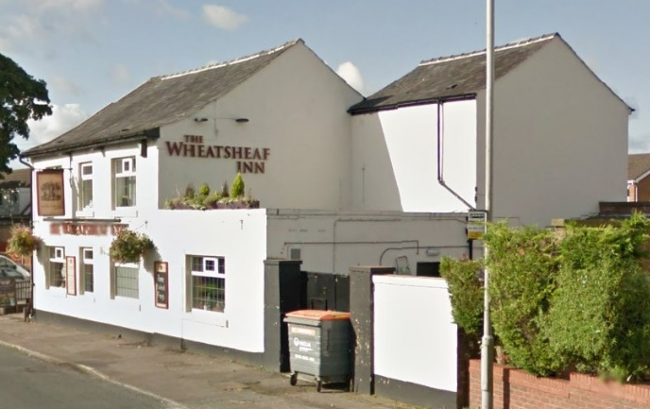 | 6 | Leyland Lane
Firs Farm Barn  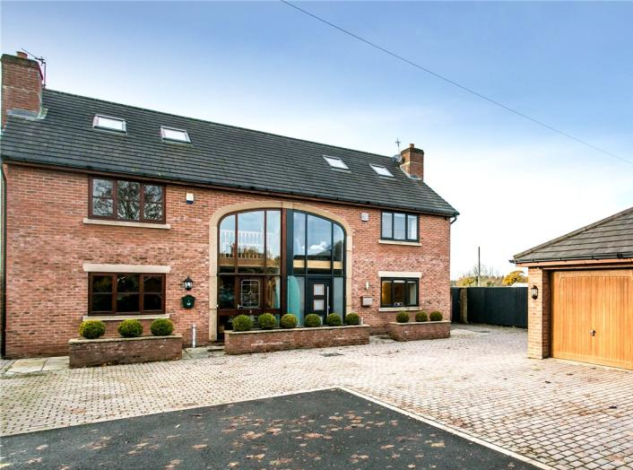  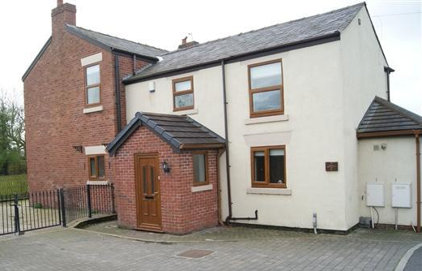 |  | Leyland Lane
Former Mill Reading Room  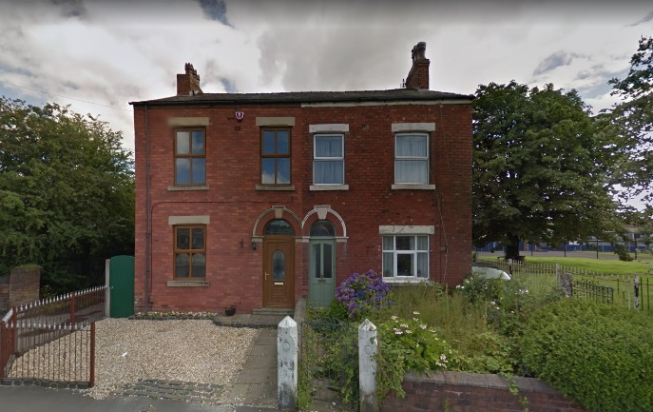 | 103-105 (odds) | Leyland Lane
Methodist Chapel  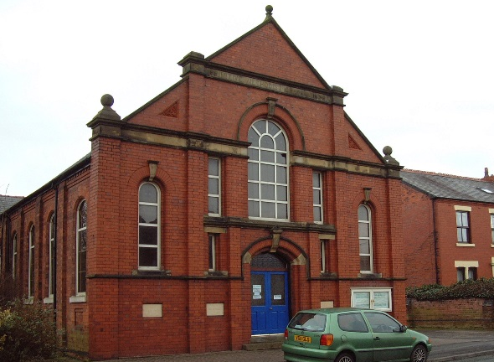 |  | Leyland Lane
Old Crook (Robinsons)  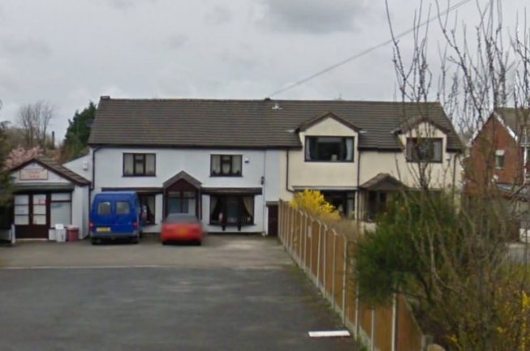 |  | Leyland Lane
Rose Hill Farm  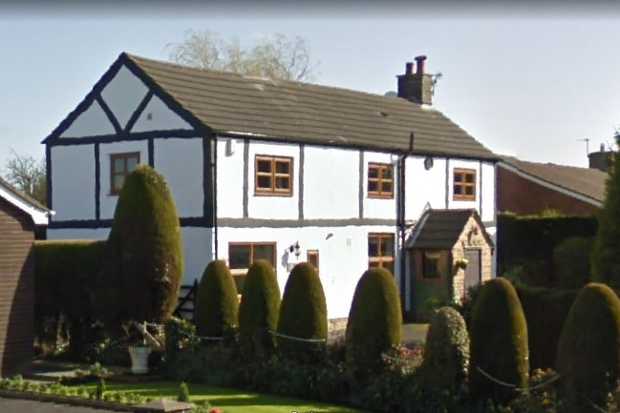 | 551 | Leyland Lane
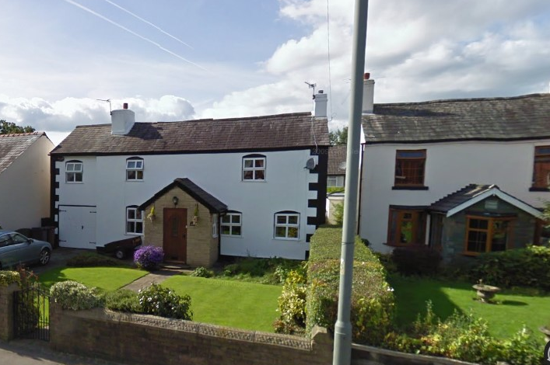 | 424 | Leyland Lane
578 Leyland Lane – Burscough House Farm

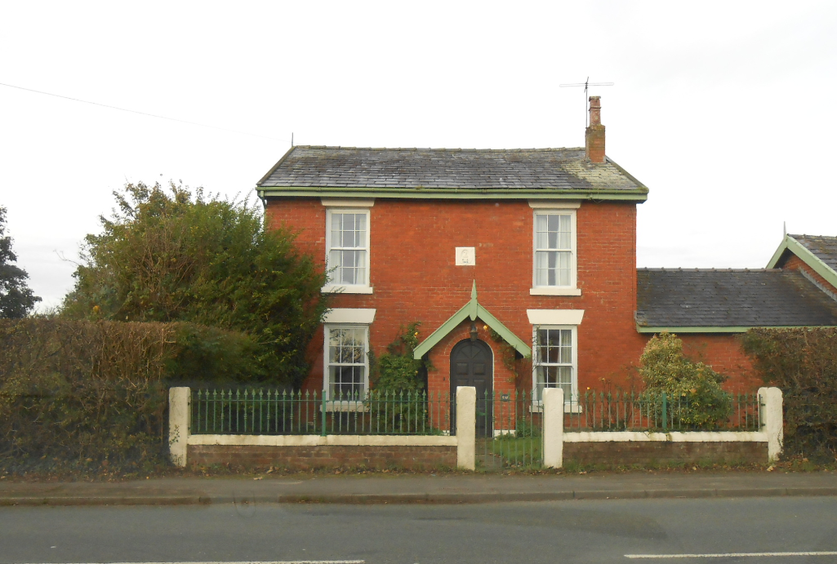
Londonderry Farm Barn  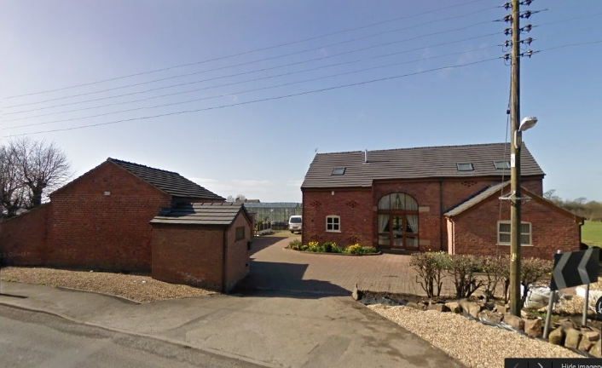  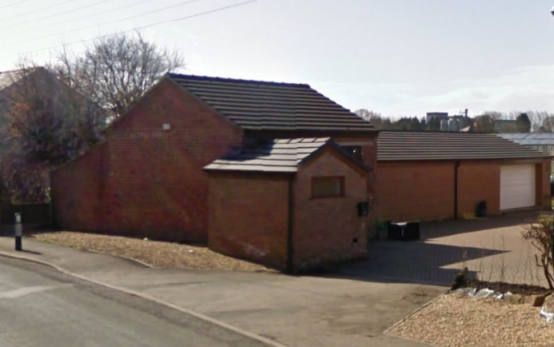 |  | Longmeanygate
Mill Weaving Shed remains |  | Mill Street
Terraced Houses  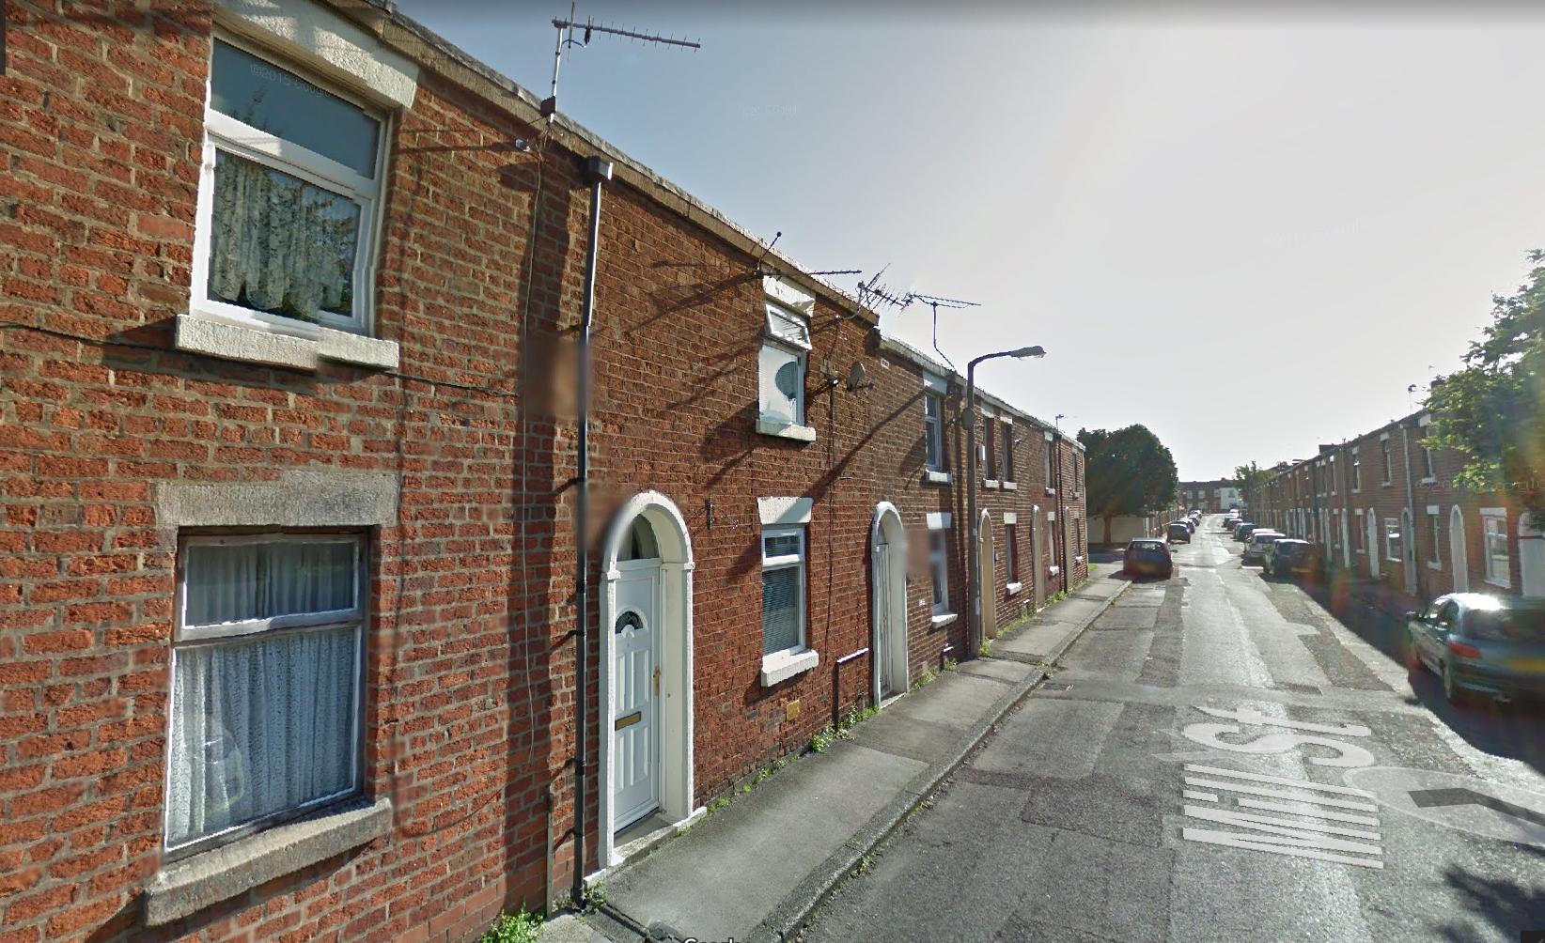 |  | Mill Street
Oaklands Convent  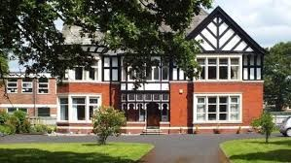 |  | Moss Lane
Iddon Brothers (former first building of BTR)  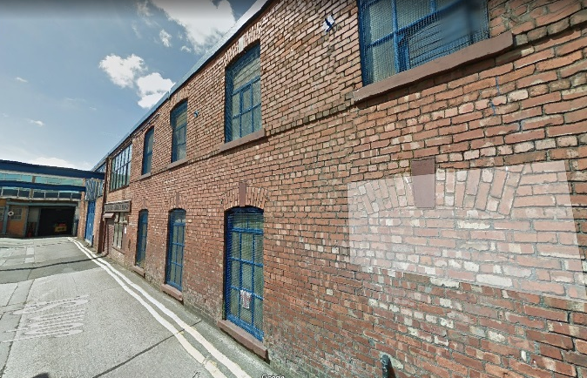 |  | Quin Street
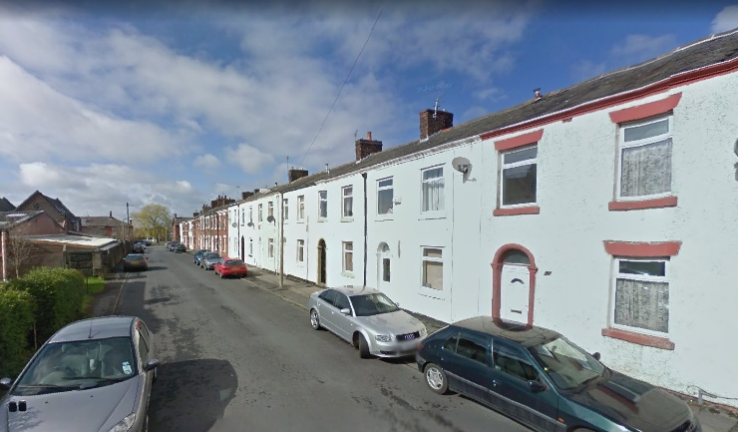  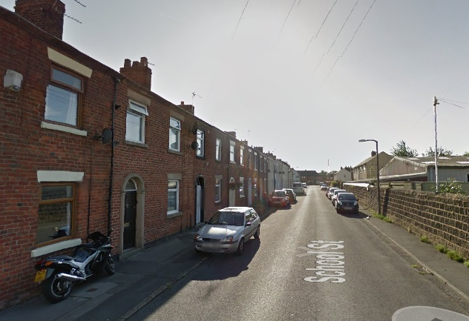 |  | School Street, Farington
Original Seven Stars  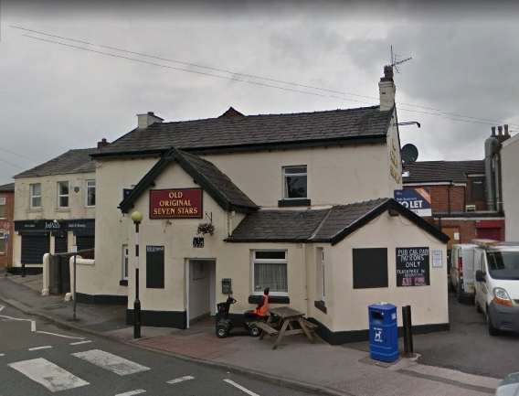 |  | Slater Lane
The Grove  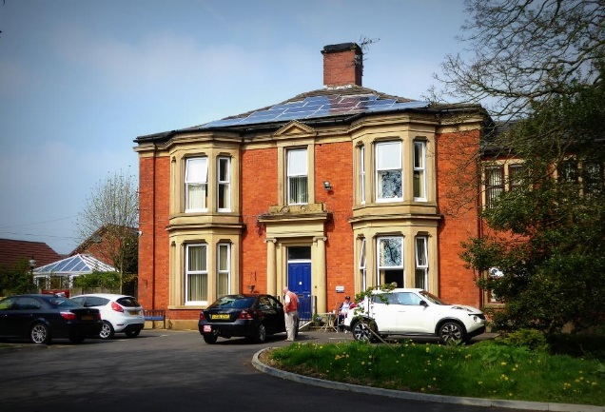 |  | Slater Lane
Conservative Club |  | Stanifield Lane
Farington Old School  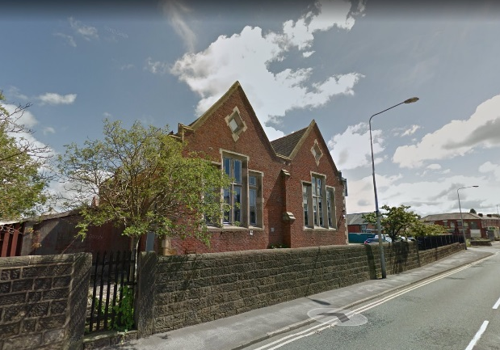 |  | Stanifield Lane
Old Mill Houses |  | Stanifield Lane
Old Post Office  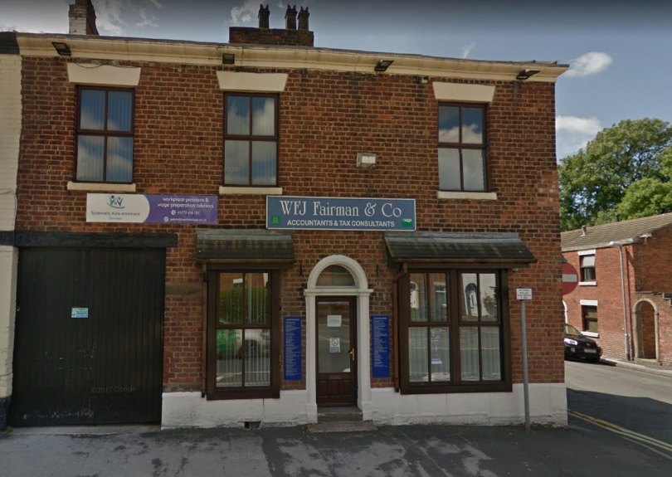 | 54 | Stanifield Lane
Rose & Crown  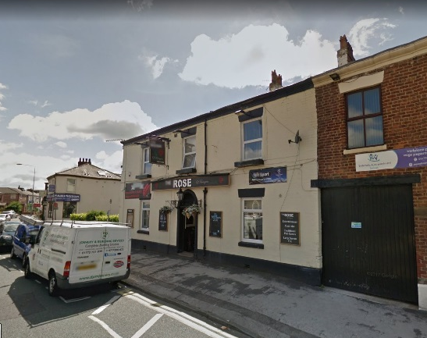 |  | Stanifield Lane
Train station booking office  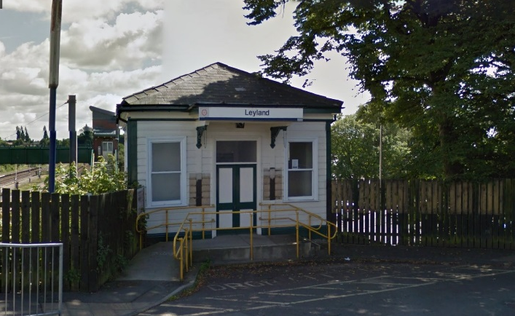 |  | Station Brow
Barristers/George IV  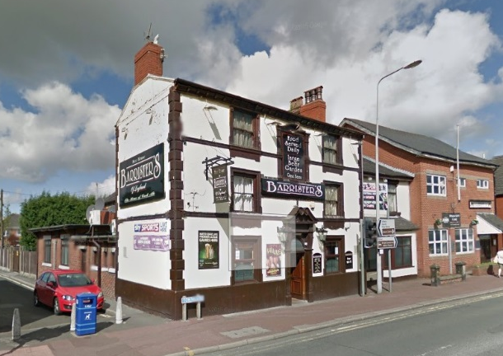 |  | Towngate
The Smithy  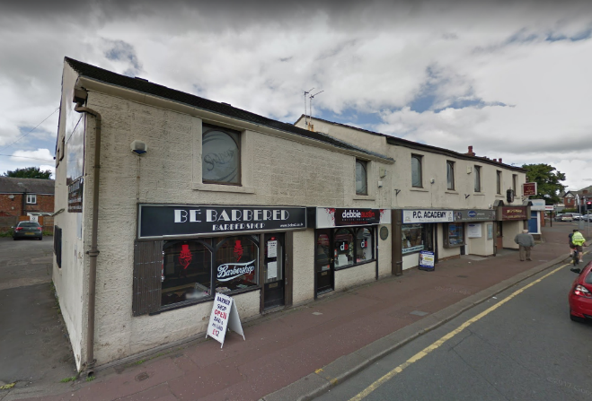 | 133-141 (odds) | Towngate
Turpin Green Cottages  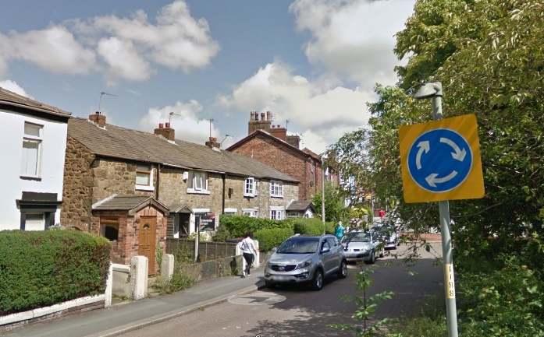 | 49-55 (odds) | Turpin Green Lane
Lancaster House  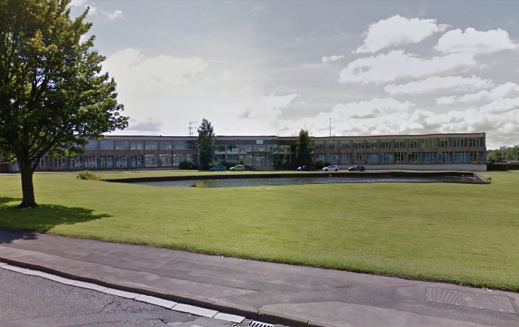 |  | Wheelton Lane
Rose Whittles Cottage/Smithy  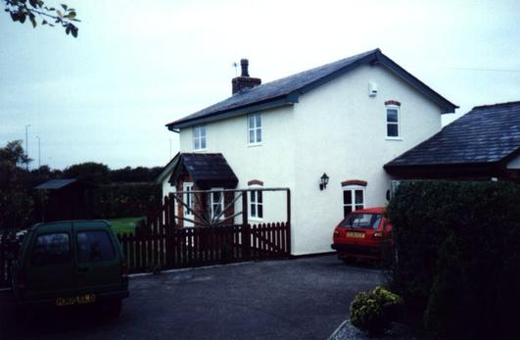 |  | Wigan Road
Swiss Lodge  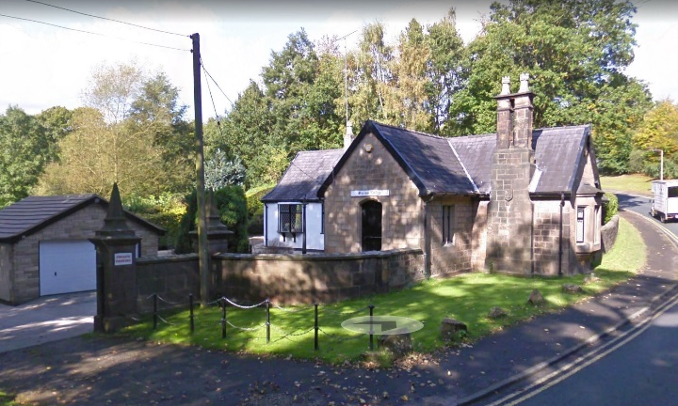 |  | Worden Park
Commercial Vehicle Museum
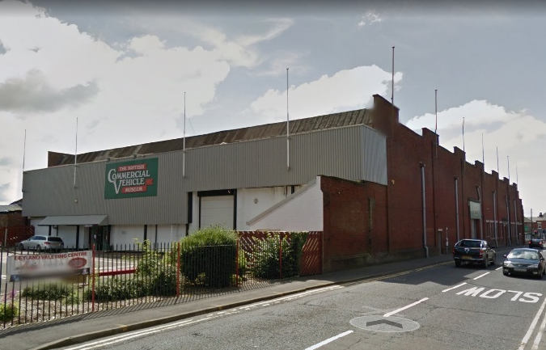
Eagle & Child bowling green

NEEDS VISIT
Leyland Cricket Club
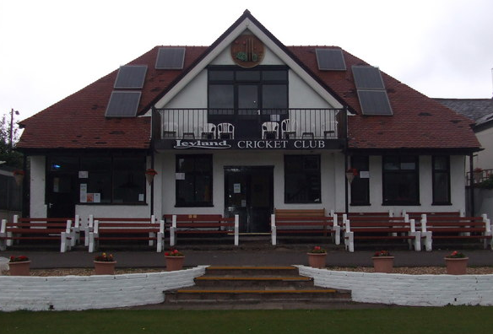

Next Steps
The draft Local List for Leyland will be subject to a six week consultation period, early in 2018. Following on from this, all responses will be carefully considered and changes made to the draft list where necessary. The List will then be formally adopted by the Council.

